C Language CheatSheet

Rajat Kumar Pandey jan 20, 2022 • 9 min read

This C cheatsheet is aimed to provide you with a quick syntax revision of C language. This will be helpful for students who need a quick syntax revision right before their exams or professionals to quickly look at the C language syntax. Let's start with the basics and move toward the more intricate aspects of C programming.

# Basics

Basic syntax and functions from the C programming language.

## Boilerplate Code

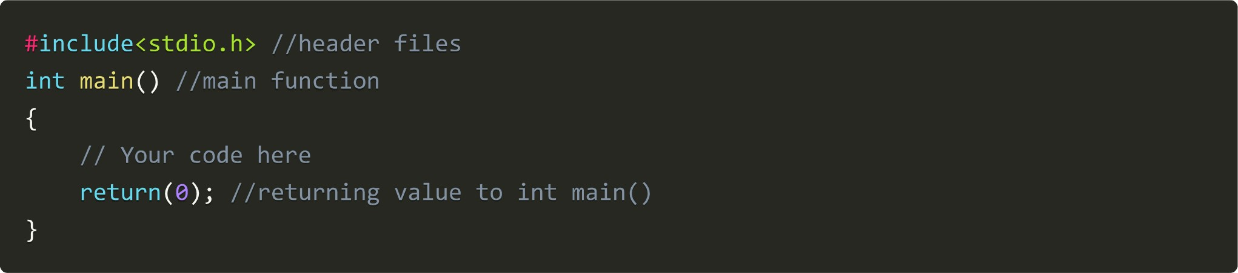

## printf function

It is used to show output on the screen



## scanf function

It is used to take input from the user



We use & with the variable name to represent "address of". This is how the syntax works:

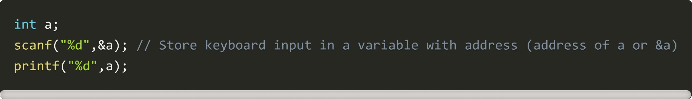

## Comments

A comment is a code that is not executed by the compiler, and the programmer uses it to annotate their code, providing explanations or reminders about the code's functionality, which aids in readability and future maintenance.

### Single line comment



#### Multi-line comment

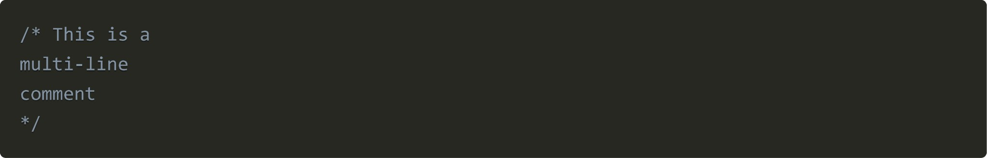

## Data types

The data type defines the kind of data that can be stored in a variable, such as integers, floating-point numbers, characters, or more complex structures. It dictates how the data is stored, interpreted, and manipulated within the program.

### Character type

The character type, often represented as a single octet (one byte), is used to store individual characters in the C programming language.



The format specifier for a character in C is "%c". To print a character, we use this specifier within the printf function, following the syntax like this:

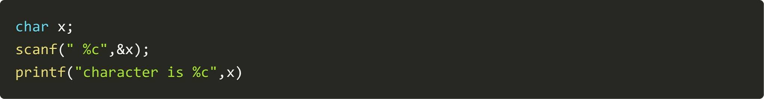

#### Integer type

To store non-decimal numeric values, an integer type is used

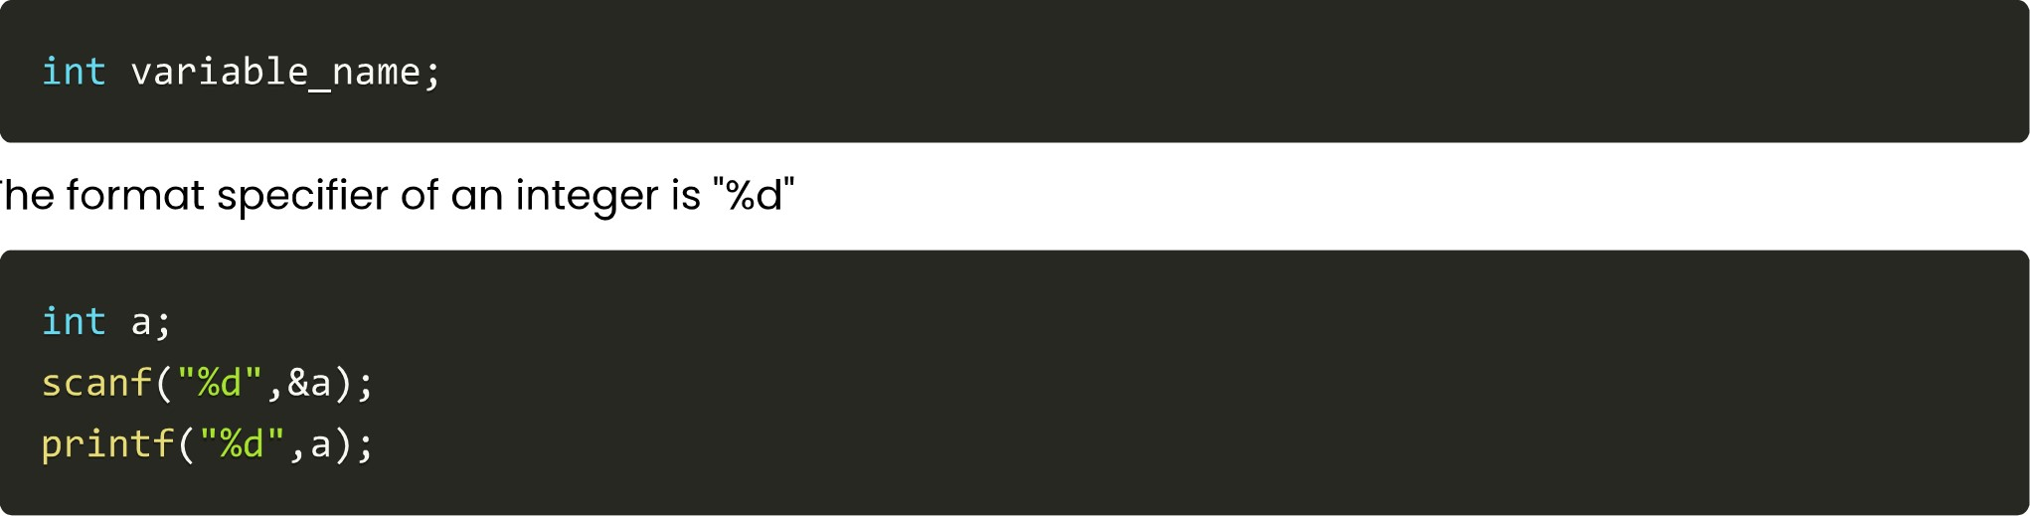

The

#### Float type

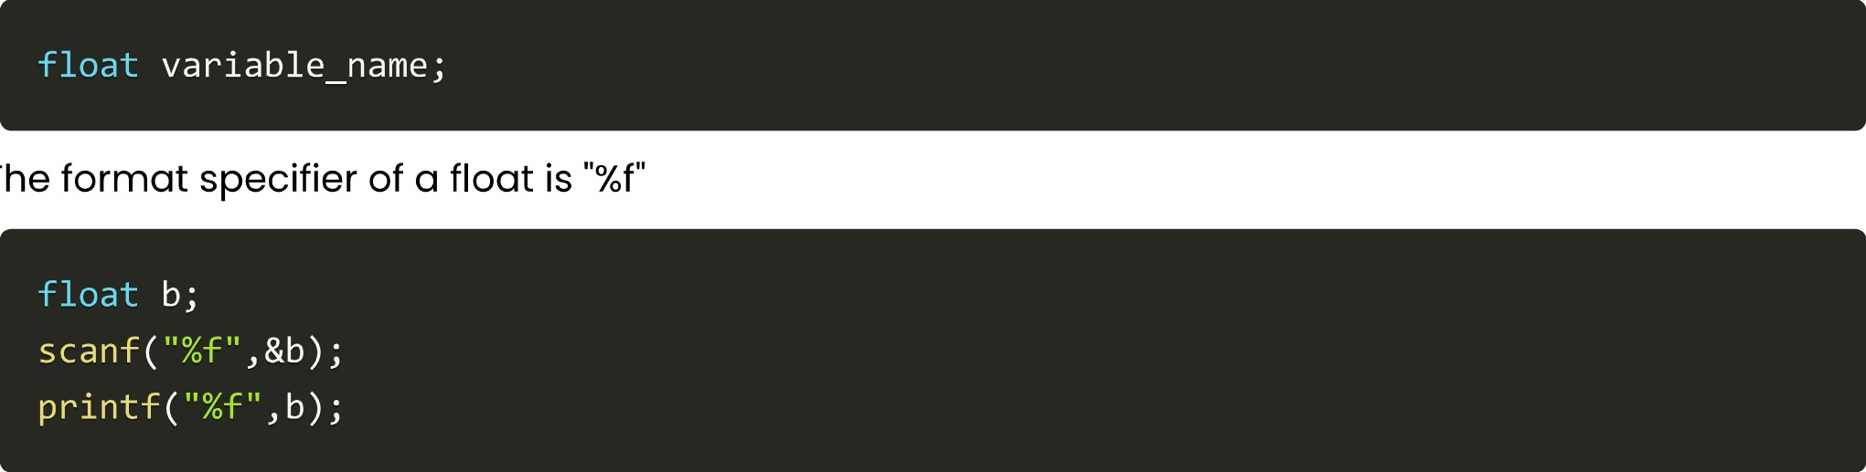

The

To

store

decimal

numeric

values,

float

type

is

used

Double

type

To store a double-precision floating-point value we use double.

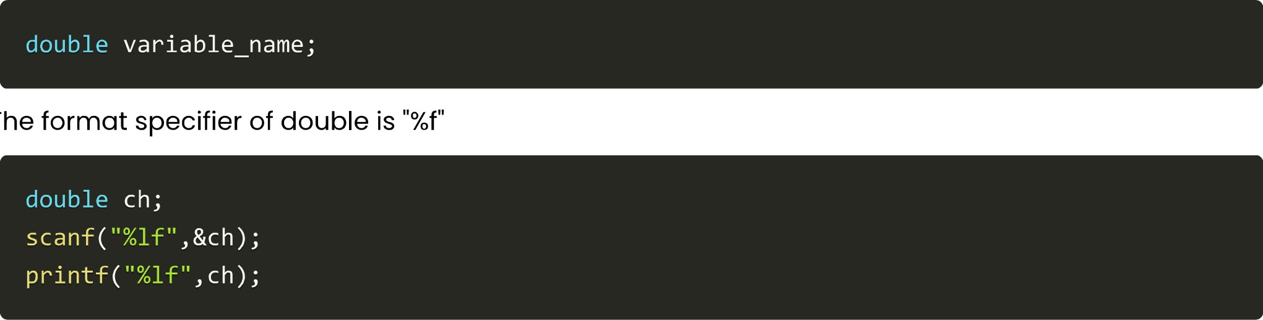

The

Void

type

The void type in C represents the absence of a type. It's often used in function declarations to specify that the function does not return any value. For example:

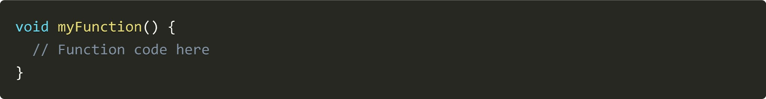

In this context, the void keyword indicates that myFunction does not return a value. It can also be used for function parameters to indicate that a function takes no arguments

## Escape Sequences

Escape sequences in C are combinations of characters that begin with a backslash ( \ ) and are used to represent characters that cannot be typed directly. These sequences are interpreted in a special way when used inside string literals or character constants.

For example, the escape sequence \n represents a newline character, and \t represents a tab character. Here are some escape sequence characters used in C language.

### Alarm or Beep

\a produces a beep sound

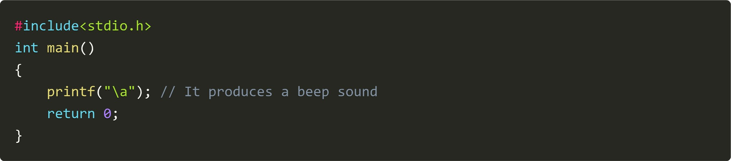

### Backspace

\b adds a backspace

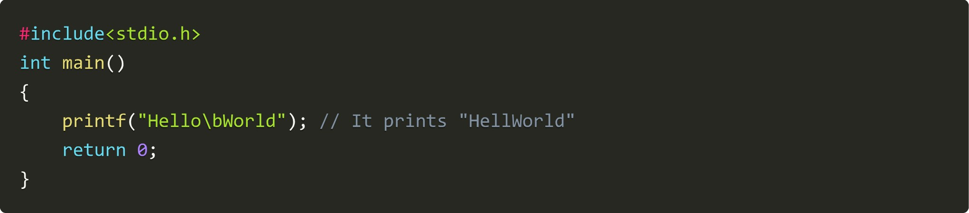

#### Form feed

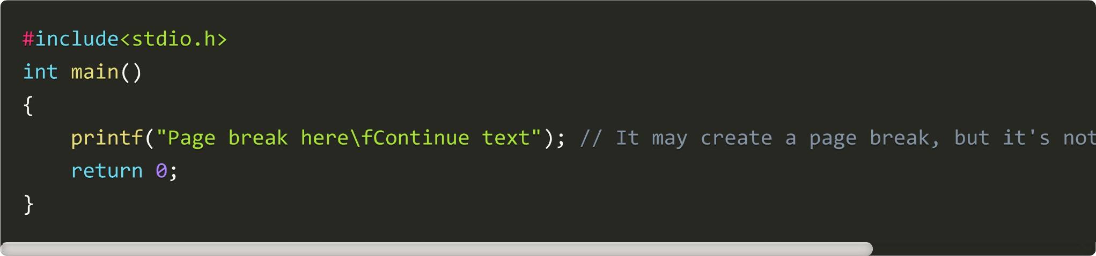

Newline

Newline Character

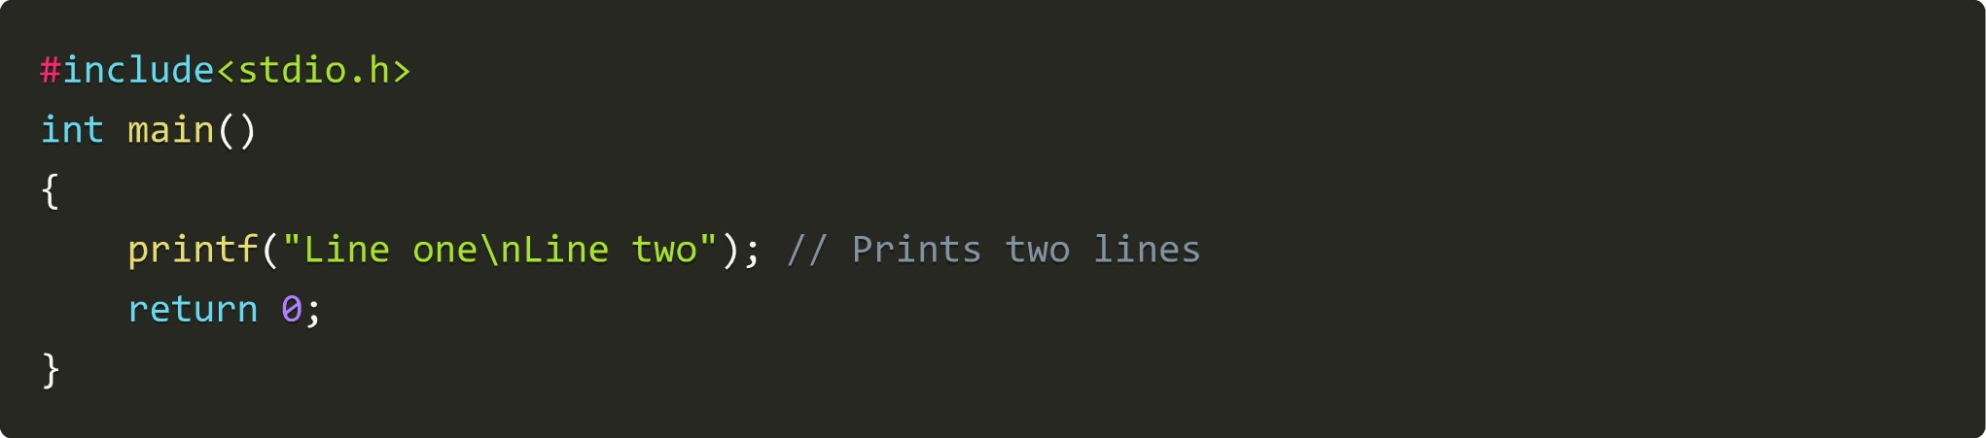

### Carriage return

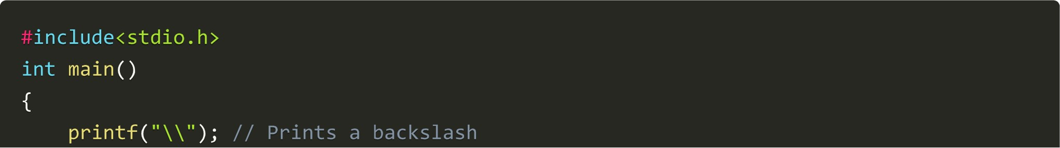The carriage return, represented by the escape sequence in the C programming language, is a control character that resets the cursor position to the beginning of the current line. It doesn't erase any characters but simply moves the cursor to the start of the line. The string "Hello" is printed first, then the carriage return moves the cursor back to the beginning of the line, and "World" is printed, overwriting "Hello."

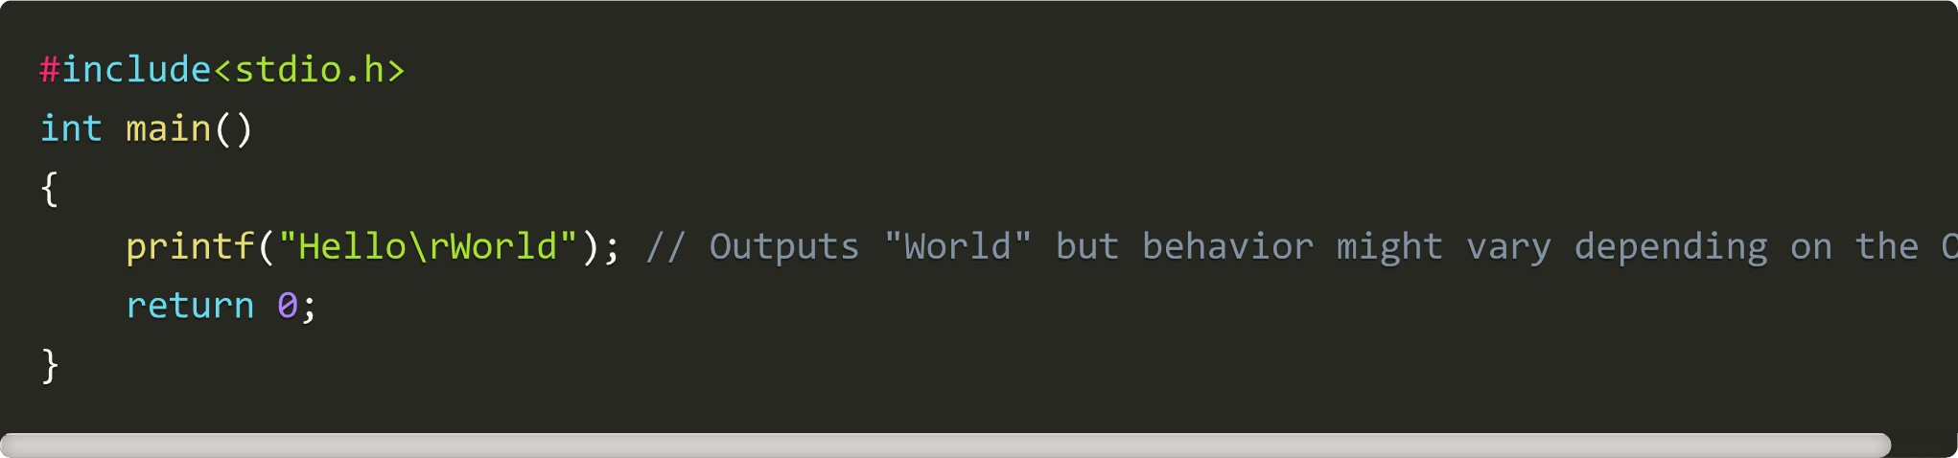

### Tab

It gives a tab space

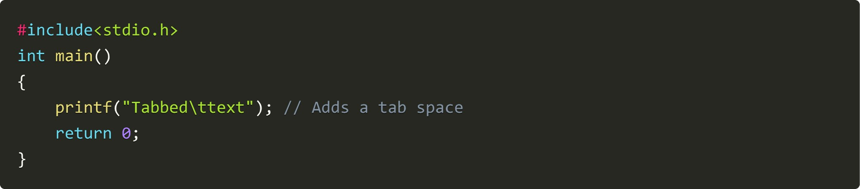

Backslash

It adds a backslash

### Single quote

It adds a single quotation mark

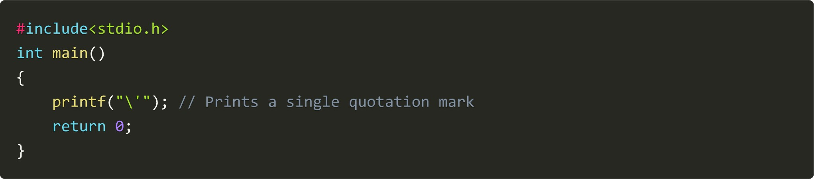

#### Question mark

It adds a question mark

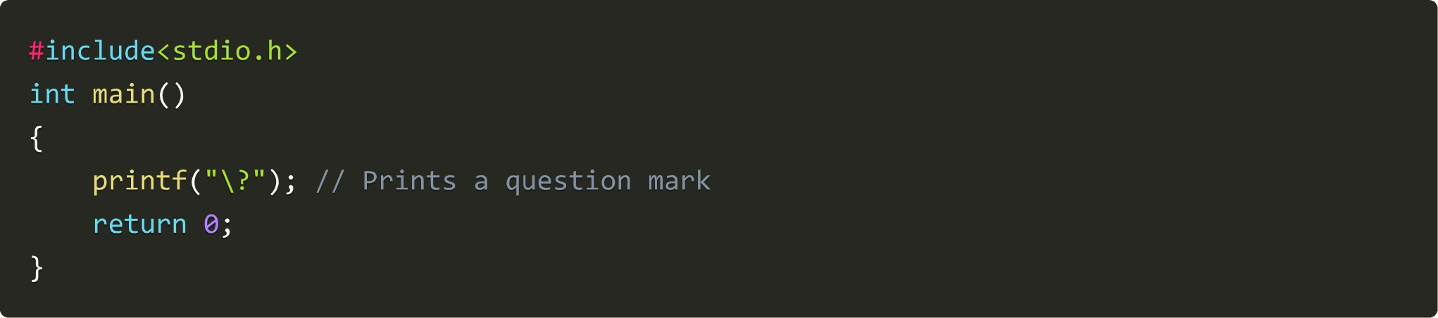

Octal No.

It represents the value of an octal number

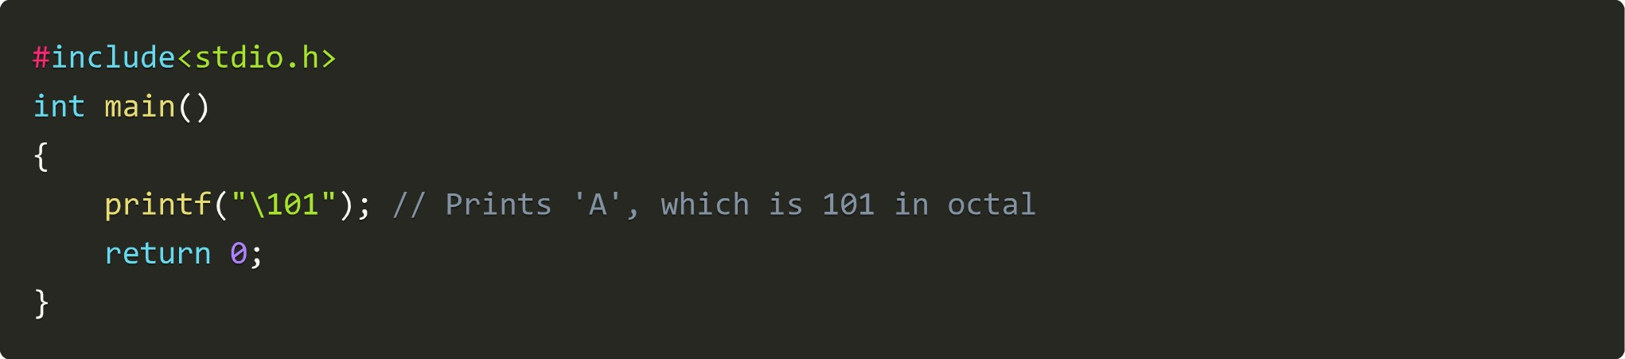

Hexadecimal No.

It represents the value of a hexadecimal number

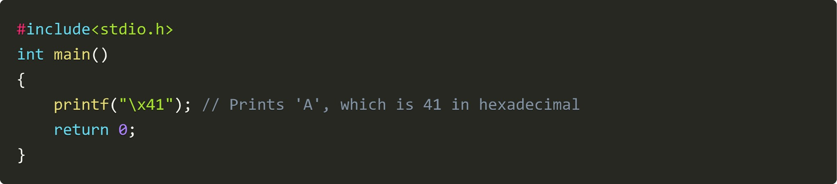

The null character is usually used to terminate a string

## Conditional Instructions

Conditional statements are used to perform operations based on some condition.

### If Statement

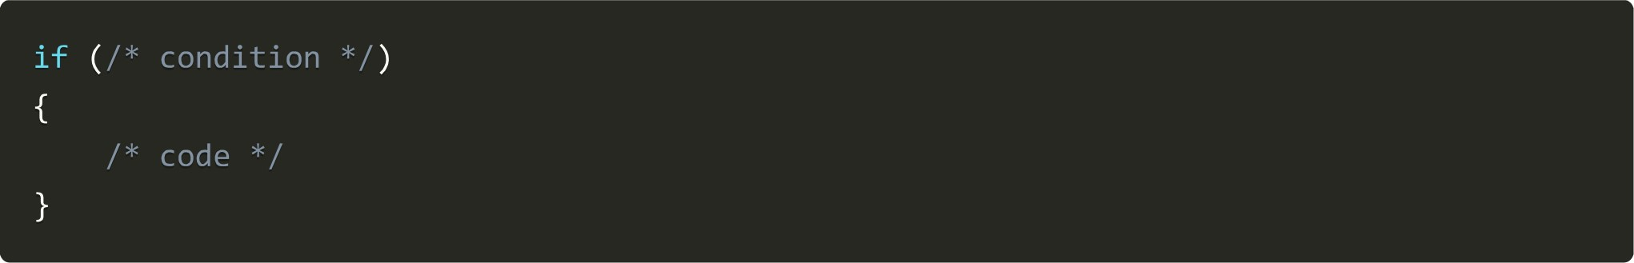

### If-else Statement

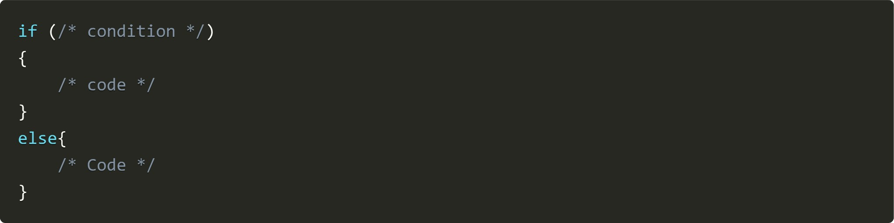

### if else-if Statement

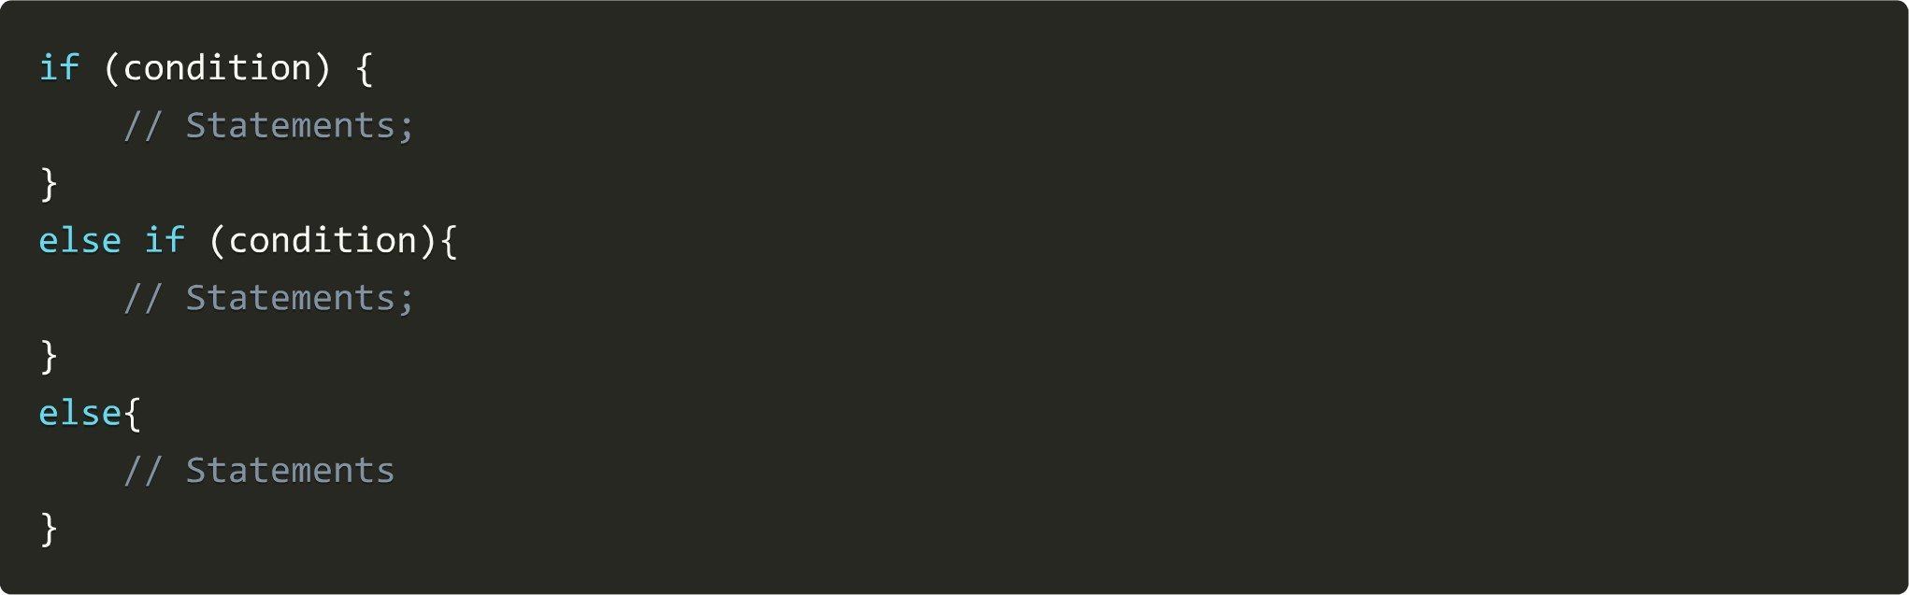

### nested if-else

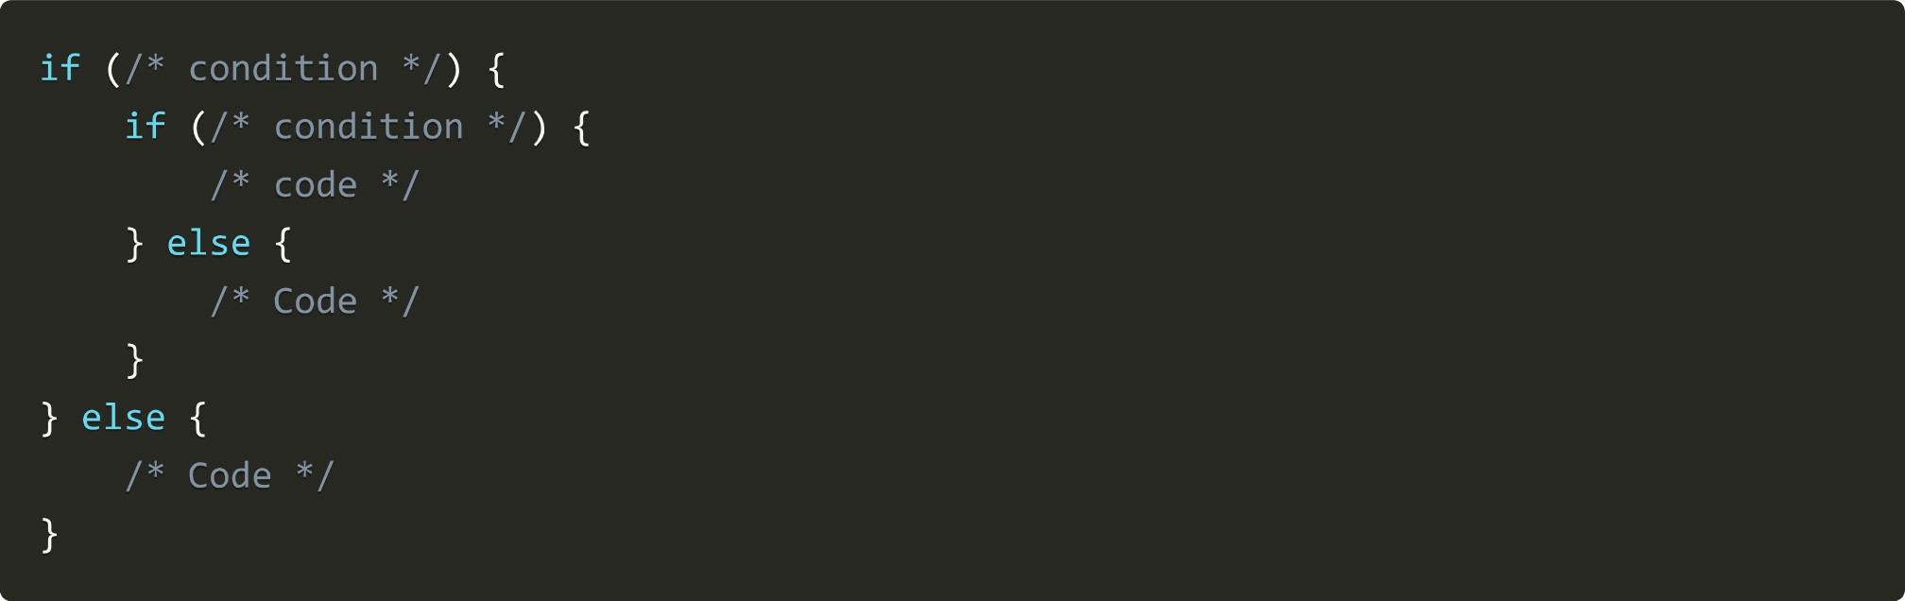

### Switch Case Statement

It allows a variable to be tested for equality against a list of values (cases).

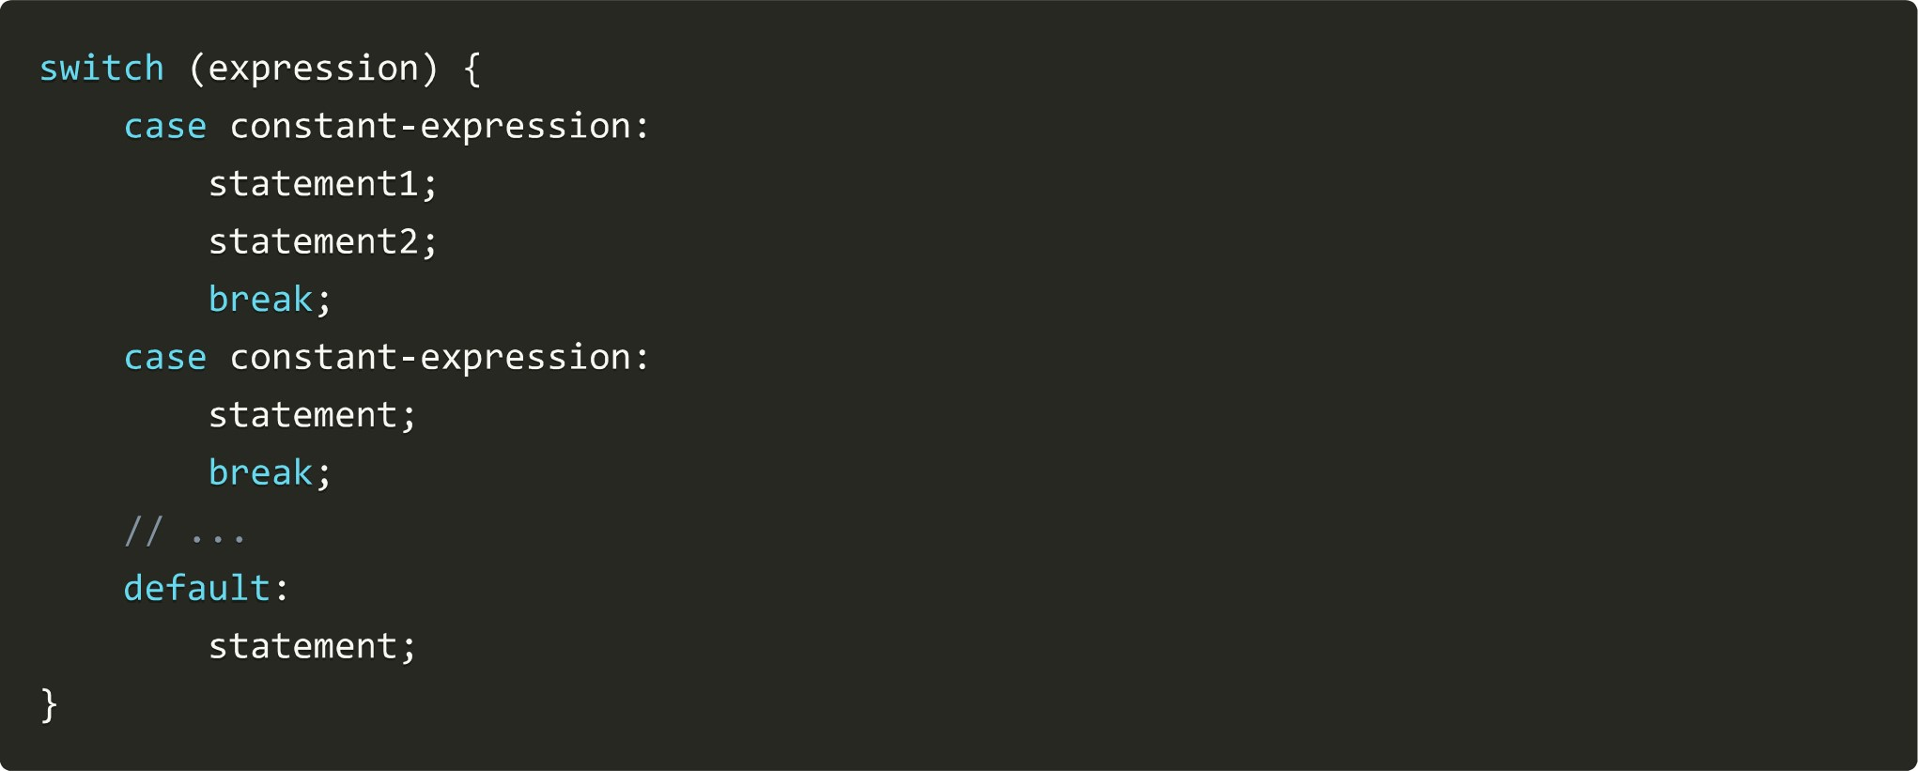

## Iterative Statements

Iterative statements facilitate programmers to execute any block of code lines repeatedly and can be controlled as per conditions added by the programmer.

### while Loop

It allows the execution of statements inside the block of the loop until the condition of the loop succeeds.

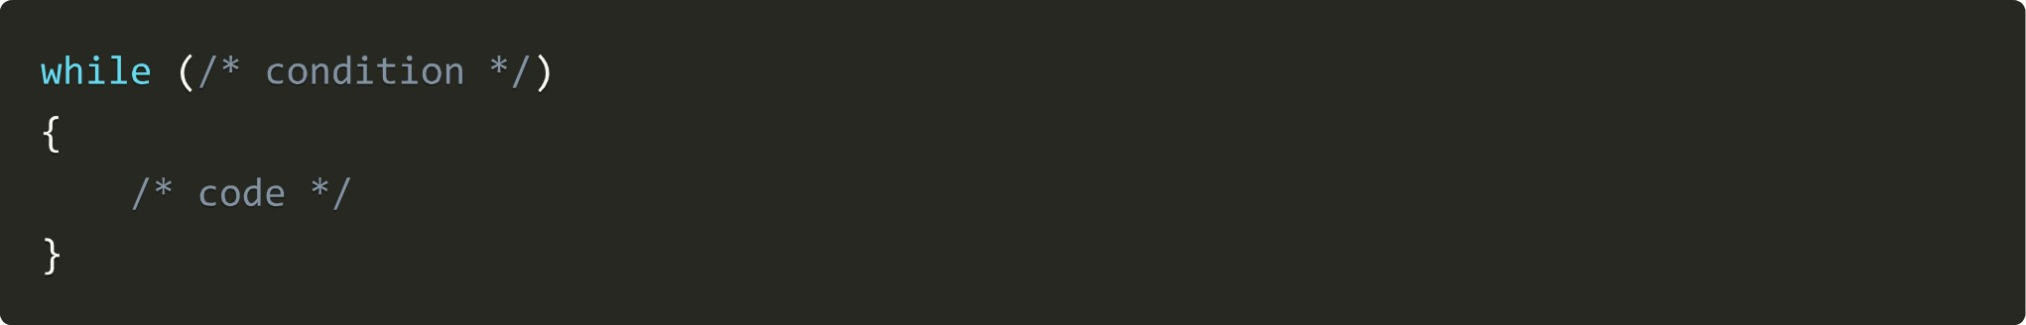

### do-while loop

It is an exit-controlled loop. It is very similar to the while loop with one difference, i.e., the body of the do-while loop is executed at least once even if the expression is false

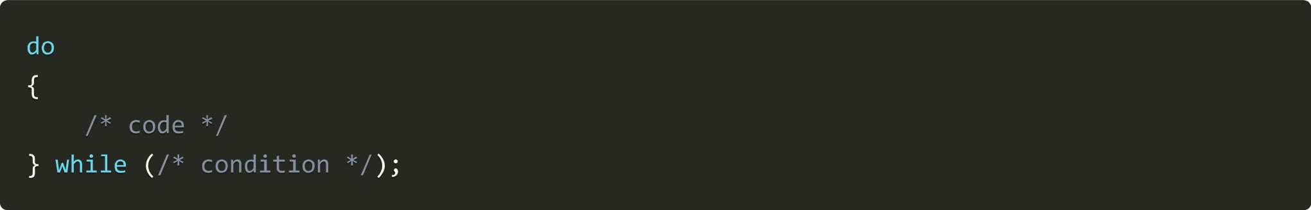

for

loop

It is used to iterate the statements or a part of the program several times. It is frequently used to traverse the data structures like the array and linked list.

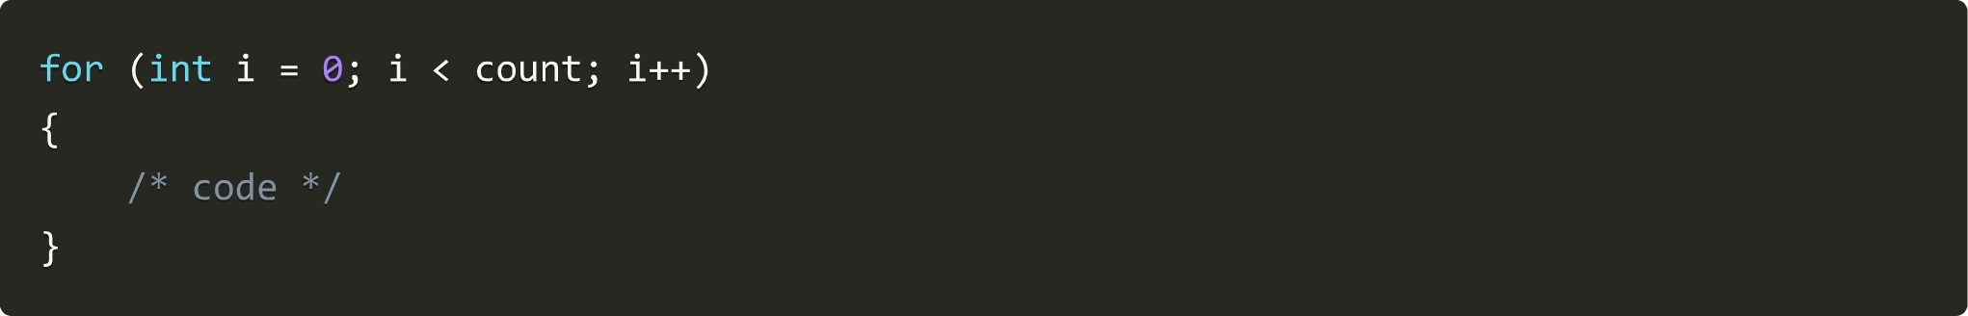

#### Break Statement

break keyword inside the loop is used to terminate the loop

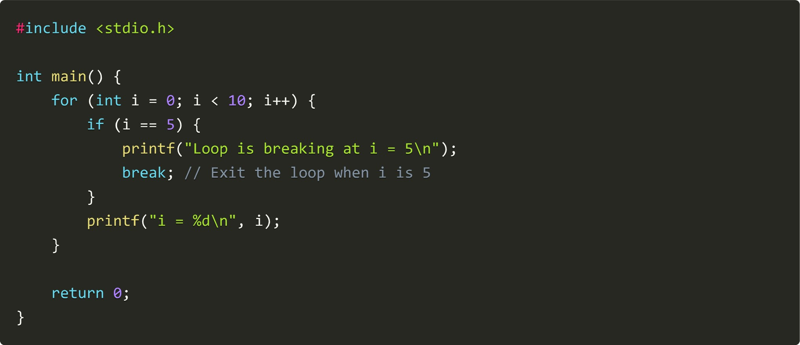

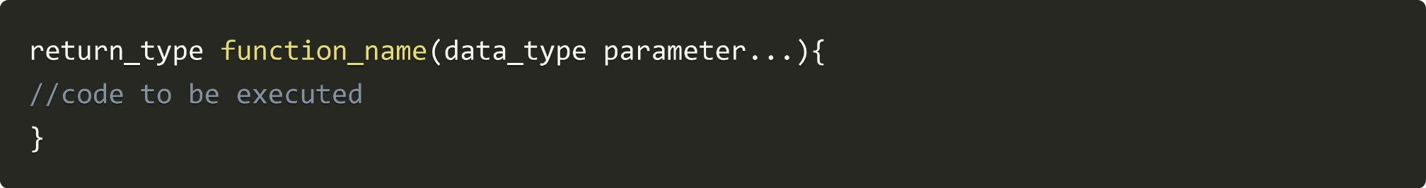Here is the output of the above code:

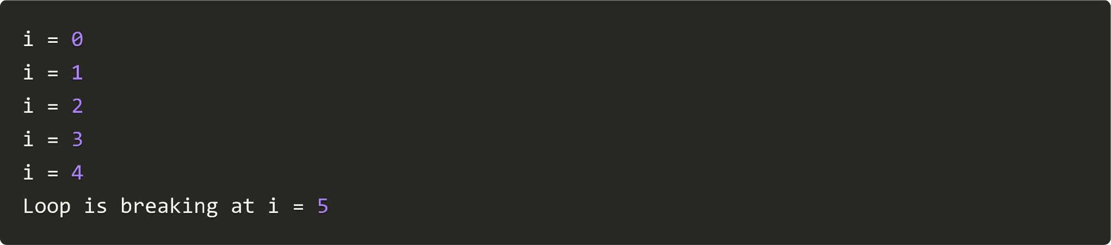

#### Continue Statement

continue keyword skips the rest of the current iteration of the loop and returns to the starting point of the loop

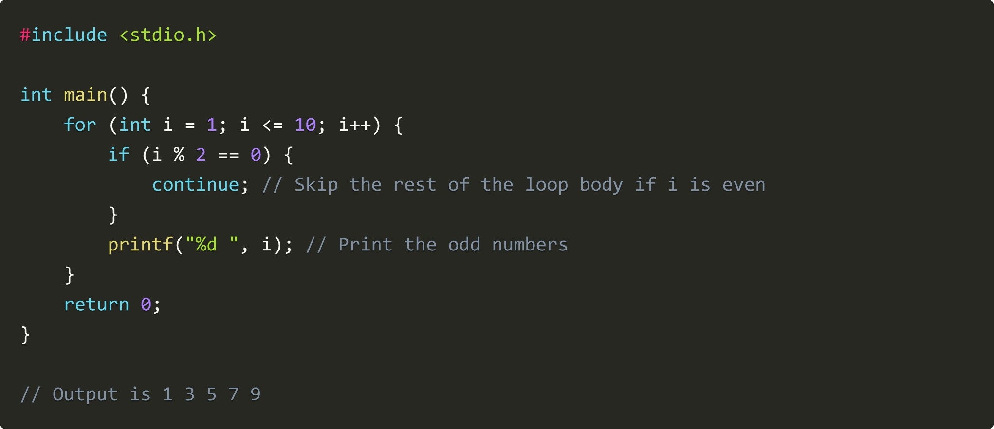

## Functions & Recursion

Functions are used to divide an extensive program into smaller pieces. It can be called multiple times to provide reusability and modularity to the C program.

Function Definition

### Function Call



### return _ type in functions

The function return statement returns the specified value or data item to the caller. If we do not want to return any value simply place a void before the function name while defining it.

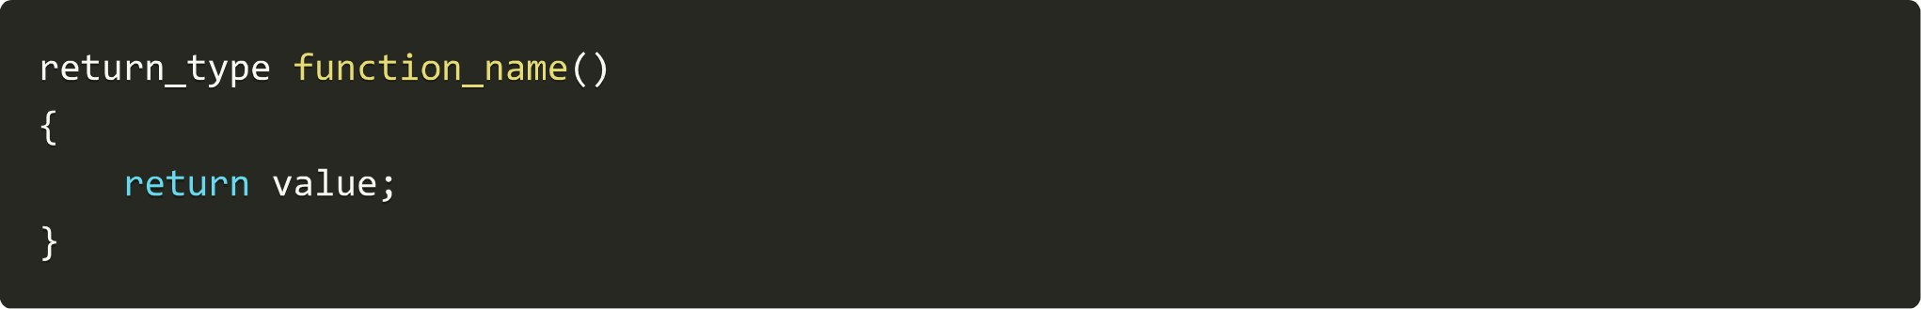

### Parameters in C function

Parameters are the values passed inside the parenthesis of the function while defining as well as while calling.

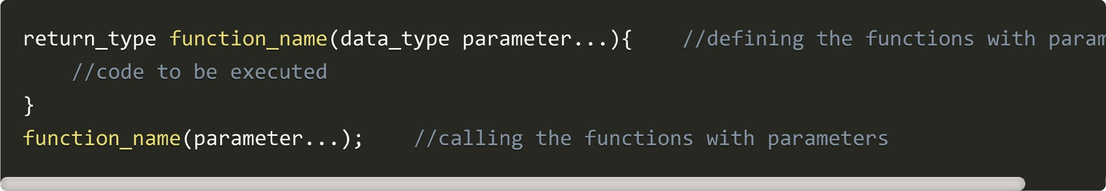

### Ways of calling a function

1. With return value and with parameters
2. Without return value and with parameters
3. With return value and without parameters
4. Without return value and without parameters

#### Recursion

Recursion is when a function calls a copy of itself to work on a minor problem. And the function that calls itself is known as the Recursive function.

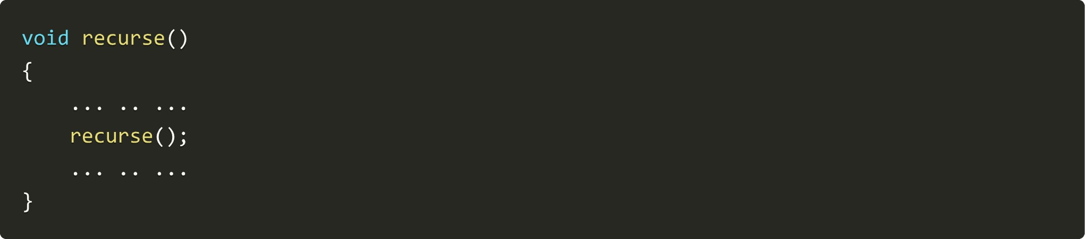

### Pointers

A pointer is a variable that contains the address of another variable,

#### Declaration



We can allocate the address of the pointing variable to the pointer variable

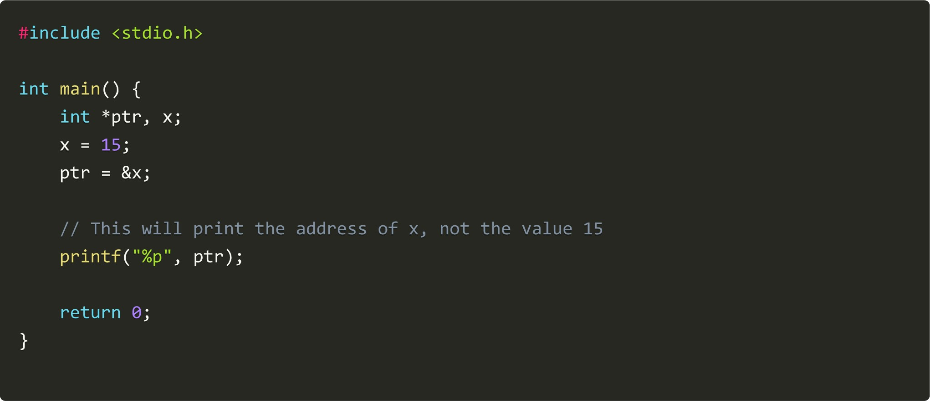

#### Dereferencing pointer variable

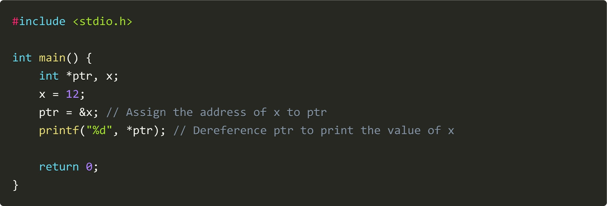

## Arrays

An array is a collection of data items of the same type.

### Declaration

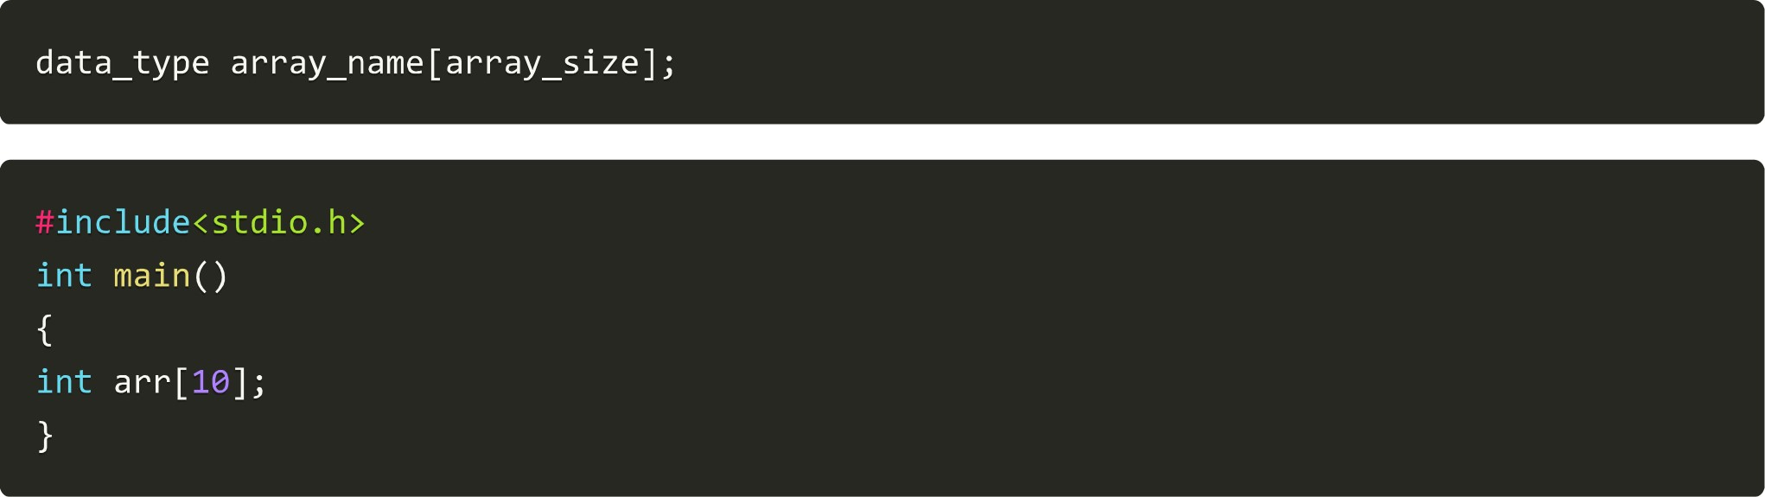

### Accessing element



## Strings

A string is a I-D character array terminated by a null character ('\0')

### Declaration



### gets() function

It allows you to enter a multi-word string.



### puts() function

It is used to show string output



### fgets() function

The gets() function is considered unsafe, and it is better to use fgets() instead.

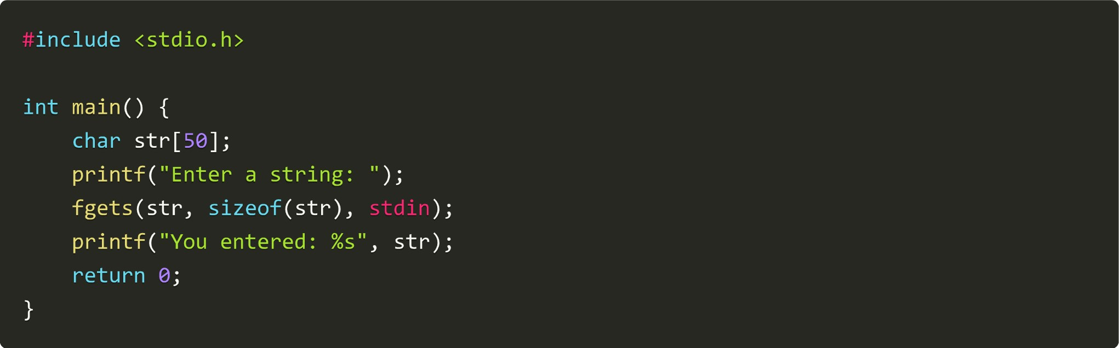

### String Functions strlen() function

It is used to calculate the length of the string



### strcpy() function

It is used to copy the content of second-string into the first string passed to it



### strcat() function

It is used to concatenate two strings



### strcmp() function

It is used to compare two strings



#### strlwr() function

It is used to convert characters of strings into lowercase



### strupr() function

It is used to convert characters of strings into uppercase



### strrev() function

It is used to reverse the string



### Structures

The structure is a collection of variables of different types under a single name. Defining structure means creating a new data type.

#### Structure syntax

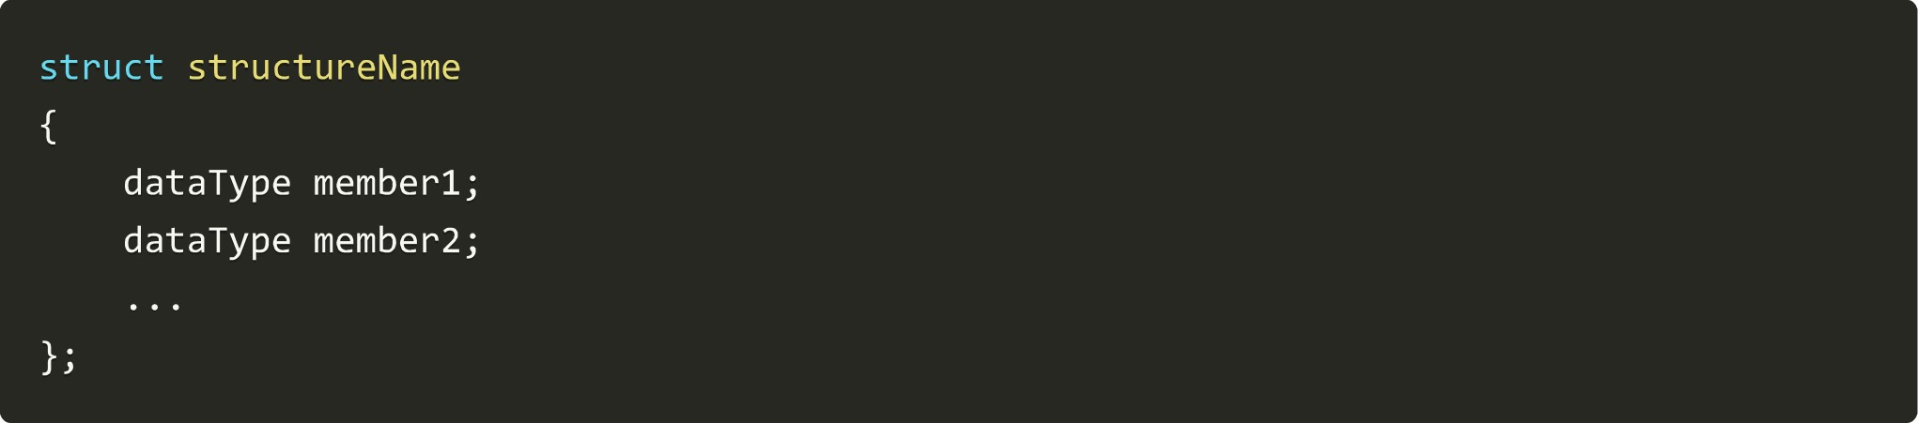

#### typedef keyword

typedef function allows users to provide alternative names for the primitive and user-defined data types.

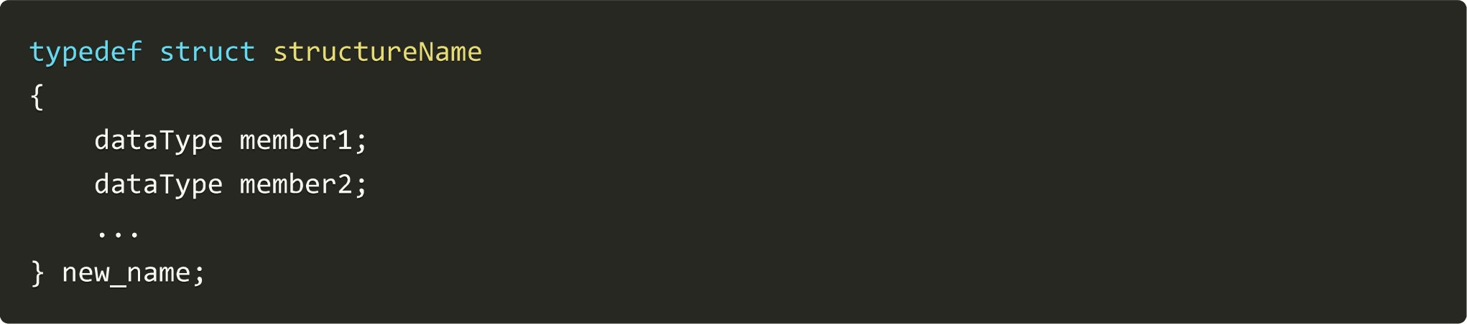

## File Handling

A set of methods for handling File 10 (read/write/append) in C language

### FILE pointer

|  |
| --- |
| FILE *filePointer; |

### Opening a file

It is used to open a file in C.



### fscanf() function

It is used to read the content of a file.



#### fprintf() function

It is used to write content into the file.



#### fgetc() function

It reads a character from a file opened in read mode. It returns EOF on reaching the end of the file.



#### fputc() function

It writes a character to a file opened in write mode



### Closing a file

It closes the file.



## Dynamic Memory Allocation

A set of functions for dynamic memory allocation from the heap. These methods are used to use the dynamic memory which makes our C programs more efficient malloc() function

Stands for 'Memory allocation' and reserves a block of memory with the given amount of bytes.

ptr (cast Type* ) malloc(size); calloc() function

Stands for 'Contiguous allocation' and reserves n blocks of memory with the given amount of bytes.



### free function

It is used to free the allocated memory.



### realloc() function

If the allocated memory is insufficient, then we can change the size of previously allocated memory using this function for efficiency purposes

|  |  |
| --- | --- |
| ptr | realloc(ptr, x); |

I hope the provided information covers what you need. I tried to cover almost all the important topics of C If you'd like to download my handwritten notes, please visit Code with Harry's Notes For your convenience, a link to download this cheatsheet as a PDF is provided below: Download this Cheatsheet as PDF